Teaching fiction in the middle years

May Seminar | Saturday 14 May, 2022

Erika Boas

Vignette 1: in Lee’s classroom
As you peer into Lee’s Year 9 English classroom you are aware of the quiet and order - a light relief after the bustle of corridors just five minutes earlier. Students are bowed over copies of Melina Marchetta’s Looking for Alibrandi (1992), following along as Lee reads aloud from the text as they will do for the next thirty minutes. Lee stops occasionally to highlight key features of the novel and asks questions to check on attention and comprehension. On some days, Lee has students take turns reading, but today they are just too unsettled for that. Students will complete chapter summaries for homework.
Vignette 2: in Tei’s classroom
Tei is wandering around the Year 8 classroom, supporting groups of students as they dissect one of the five scenes they will study from the novel, Detention (2019) by Tristan Bancks. Tei began the class by reading aloud the opening scene as students followed along with the photocopy of that scene. Written on the board are multiple inquiry questions about meaning and language, and Tei is leaning into one group as they work through the inquiries in preparation for reporting back at the end of the lesson.
Vignette 3: in Kirby’s classroom
Kirby’s Year 10 students are scattered in groups around the classroom, and it’s not clear what novel they are studying because in one group each member appears to have the identical text, while in other groups the novels are all different. At the moment, Kirby is screening an extract from a popular film to teach the concept of inference and directing students to spend the next ten minutes sharing their understanding of the concept and identifying examples of inferences from their texts. For the final ten minutes of the lesson, they will be returning to their desks to complete some writing using three extracts from their novels to consolidate their responses and learning.
Vignette 4: in Amida’s classroom
Amida has been addressing this question with the class: “How do you, or people you know, try to preserve the past?” Now Amida guides the students to consider the same question as they listen to the poem ‘Knock Knock’ by Daniel Beaty (2018). The lesson will continue with students documenting how they believe people preserve the past (in their lives or in the poem). Amida has explained that she is expecting students to build links between this class discussion, the poem she is about to read and ideas or language within the opening pages of the verse novel, The Art of Taxidermy (2018) by Sharon Kernot. Students are then challenged to find evidence from the opening pages to answer these questions: How and why do you, the people you know, or the characters from the poem or the verse novel, attempt to preserve or recreate the past?
Vignette 5: in your classroom
Aspects of the previous four vignettes allow you to peek inside other classrooms that may or may not be familiar to you and may or may not fit with your beliefs and practices as a teacher of English. Of course, there are infinite possibilities for the vignettes we might present, but the idea is to provoke a response so that you might create your own aspirational vignette.

Text audit | ✓ and then add D if the text is a digital text
Whose perspective? | Non-fiction  (prose - extended and short) | Fiction (Imaginative)  (prose - extended and short) | Film, video, TV | Aural | Poetry | Drama | Interactive | Still images
Australian – (non First Nations author):
First Nations author:
Asian:
North American:
British:
Other cultures – especially of students in your school:
LGBTQI+:
Male, female or other
protagonist:
Male or female author/
creator:
Date of publication:
A focus on the outlook or perspective:
E.g. bleak or full of hope?
Historical period:
Social class:
Potential sensitivities/ triggers:
Other:

Emily’s story: Using Book club approaches
Emily Frawley (Vic) adopts Book club pedagogy in her teaching. The following example, from one of her Year 7 classes, highlights the pedagogy and ways it can be adapted for use with any age group.

For Emily’s literature unit, the intended outcomes were:
- engaging with and discussing ideas
- collaborating with peers
- forming opinions based on evidence
- drawing on academic phrasing.
In this activity, Emily uses the term ‘Book club’ with a focus on group discussion and moves away from ubiquitous comprehension questions. The teacher chooses a passage and a ‘provocation’ as the basis of discussion. For example, a snapshot below uses the provocation, ‘Is Sameness a good thing?’ in response to The Giver (1993). The Giver explores a dystopian world that employs the euphemism of ‘Sameness’ as a rationale for a world that has removed pain, but also joy.
- After reading the passage together in their Literature circle or Book club, with the provocation discussion as their purpose, the students complete a think/pair/share as a way of forming an initial response in pairs or small groups.
- Following this paired/small group work, the teacher elicits answers and writes them up on the board. Students are directed to provide quotes as evidence for their answers.
- After the whole class has copied down the board notes and a range of possible responses, they are given time to write their own response to the provocation as a ten minute ‘quick write’. The teacher provides some further sentence starters, academic vocabulary, and punctuation reminders for students to challenge themselves to draw on in their writing.
- Following this ten minute ‘quick write’ students share their responses with the class. The fact that students have already verbally rehearsed their response usually provides ample volunteers wanting to share their writing.
Setting the provocation and assigning an extract
In this passage, the protagonist, Jonas, is learning about what the world was like before Sameness. The provocation for this passage was, ‘Is Sameness a good thing?’
“But now that I can see colours, at least sometimes, I was just thinking: what if we could hold up things that were bright red, or bright yellow, and he could choose?
Instead of the Sameness.”
“He might make wrong choices.”
“Oh.” Jonas was silent for a minute. “Oh, I see what you mean. It wouldn’t matter for a new child’s toy. But later it does matter, doesn’t it? We don’t dare to let people make choices on their own.”
“Not safe?” The Giver suggested.
“Definitely not safe, “Jonas said with certainty. “What if they were allowed to choose their own mate? And chose wrong?
“Or what if,” he went on, almost laughing at the absurdity, “they chose their own jobs?”
“Frightening, isn’t it? The Giver said.
Jonas chuckled. “Very frightening. I can’t even imagine it. We really have to protect people from the wrong choices.”
“It’s safer.”
“Yes,” Jonas agreed. “Much safer.”
But when the conversation turned to other things, Jonas was left, still, with a feeling of frustration that he didn’t understand. (pp. 97-98)
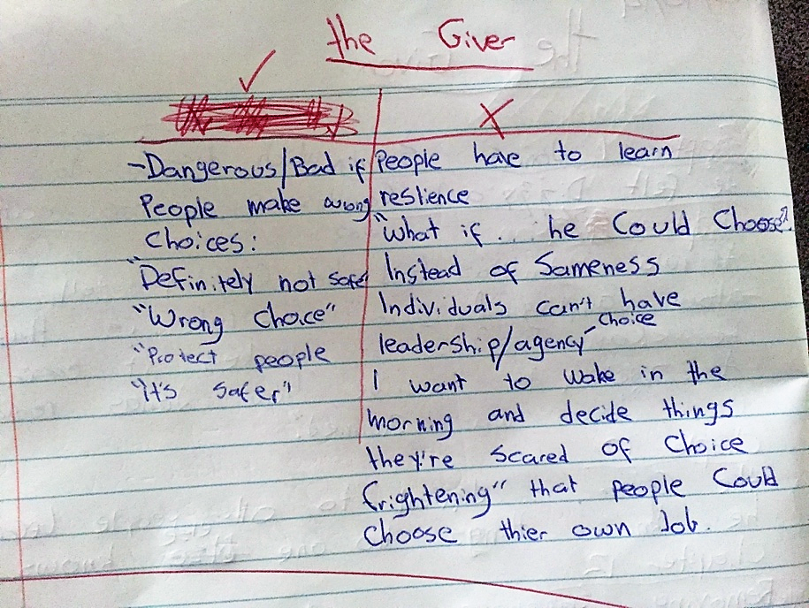

The prompts given for this quick write were the topic sentence (‘In The Giver choice has been taken away from the community’), and the sentence starters: ‘This is a good/bad thing because…’, ‘This is shown through the quote, “_____”, ‘ Lowry makes readers think about…

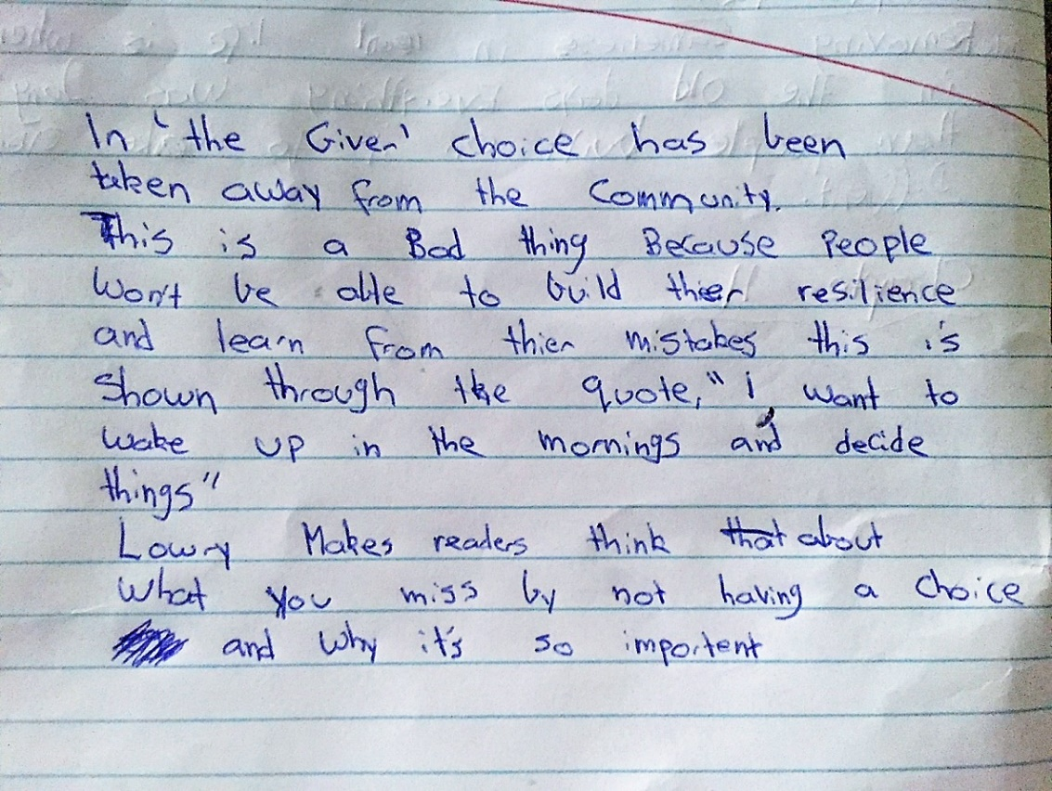

The strength of this approach is that it is a continuous loop - through repeated exposure to this style of learning, students have opportunities to build, rehearse and reinforce their skills. This model encourages students to see that reading the class novel is not just about ‘knowing what happens’ in the narrative, but using it as a starting point to discuss ideas.

Rosie’s story: ‘Forensic’ reading (also referred to as Close reading)
Rosie uses the term ‘forensic reading’, not because students are examining a crime, but rather students work as groups of detectives to analyse and evaluate scenes from novels to better understand how they work, and how they can uncover the craft and decision-making of the writer.

The benefit of such close reading of extracts is for students to consider each of the following, without knowledge of the bigger picture of the narrative:
- Focus on how professional writers craft images, sentences, dialogue, and scenes.
- Consider what decisions may have been made: why this name for a character and not another? Why this verb and not another? Why this image and is it effective?
- Use numeracy to make reading and writing more concrete and quantify language as an entry point for those who regard writing as too ethereal. For example, what ratio of adjectives to total words does this author use that I can then apply in my writing? Can I construct three opening sentences using the same grammar and word count per sentence, such as three words, 12 words, 25 words and so on. Using the mentor text in these practical, measurable ways can give some students more structure and confidence.
- Invite students to discuss and then articulate what the writer is doing and the rules they use for dialogue, sentence boundaries and commas, and for linking paragraphs.
- Support students to write using a similar style by scaffolding paragraphs with the same sentence starters used by the writer.
- Use as many analysis and co-construction activities in groups as possible, and in doing so reduce teacher talk with increasing student engagement, independence, and accountability in textual analysis.
- Practise in their groups using the vocabulary of literary analysis that you will explicitly teach. Using such vocabulary frequently in discussion is a necessary step to using it confidently and correctly in written responses.

