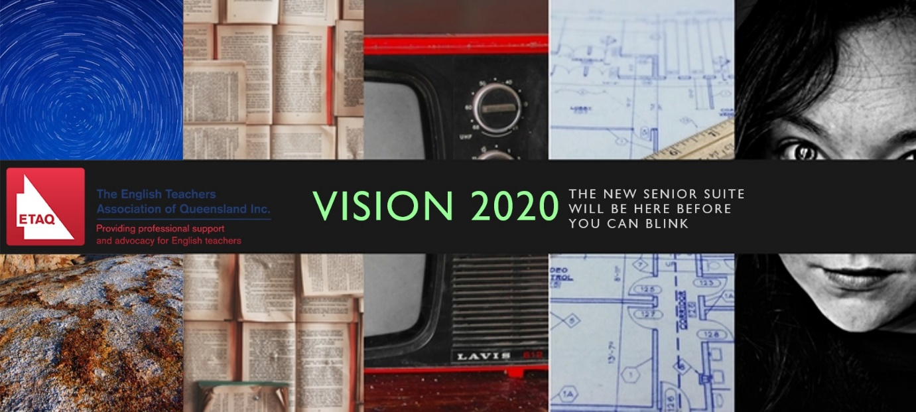
Date Claimer
Master Class 1: Unit 3
9am – 3pm on 19 and 20 May
University of Queensland, St Lucia

ELABORATION
Our Year 12 Masterclasses create the opportunity for English teachers to work with experts from the Queensland Curriculum and Assessment Authority, access the latest in Queensland-based scholarly research into effective assessment practices, and be supported by experienced peer practitioners. Run over two full weekends in 2018, this ambitious professional learning event will be aligned with Units 3 and 4 of the various Senior English Syllabus documents – English, Literature, English as an Additional Language, and Essential English. Participants will receive careful explanation of one semester unit of their selected syllabus, then participate in a structured thinking and planning day. At the end of each of four days, participants will be confident in designing and delivering complete unit plans for Year 12 (Units 3 and 4) so it’s perfect for teams and leaders – as well as individual classroom teachers who wish to develop their own knowledge. This event considers Unit 3; Unit 4 will be addressed at the second weekend event, on 20th and 21st October 2018.

FORMAT
The program for Saturday 19 May will deal with English and Literature while the program for Sunday 20 May will cover English, EALD and Essential English.
Participants may register for Saturday, or Sunday or both days

Keynote  9:10-10:30 | The keynote for each syllabus strand will be presented by an ‘expert’ in the field. They will unpack Unit 3 in the syllabus and consider classroom implications for teachers.
10:30-11 Morning Tea
Session 2  11-12:30 | Focus on Unit 3  - Deconstruction and discussion of exemplar teacher work  - Guided activities on generating tasks and mapping units of work
12:30-1:30 Lunch
Session 3  1:30-3 | Developing student skills – teaching the new syllabus  - Readiness/independence  - Flexibility in thinking

Program available and registrations open on Wednesday 11 April
Registrations close Friday 11 May

