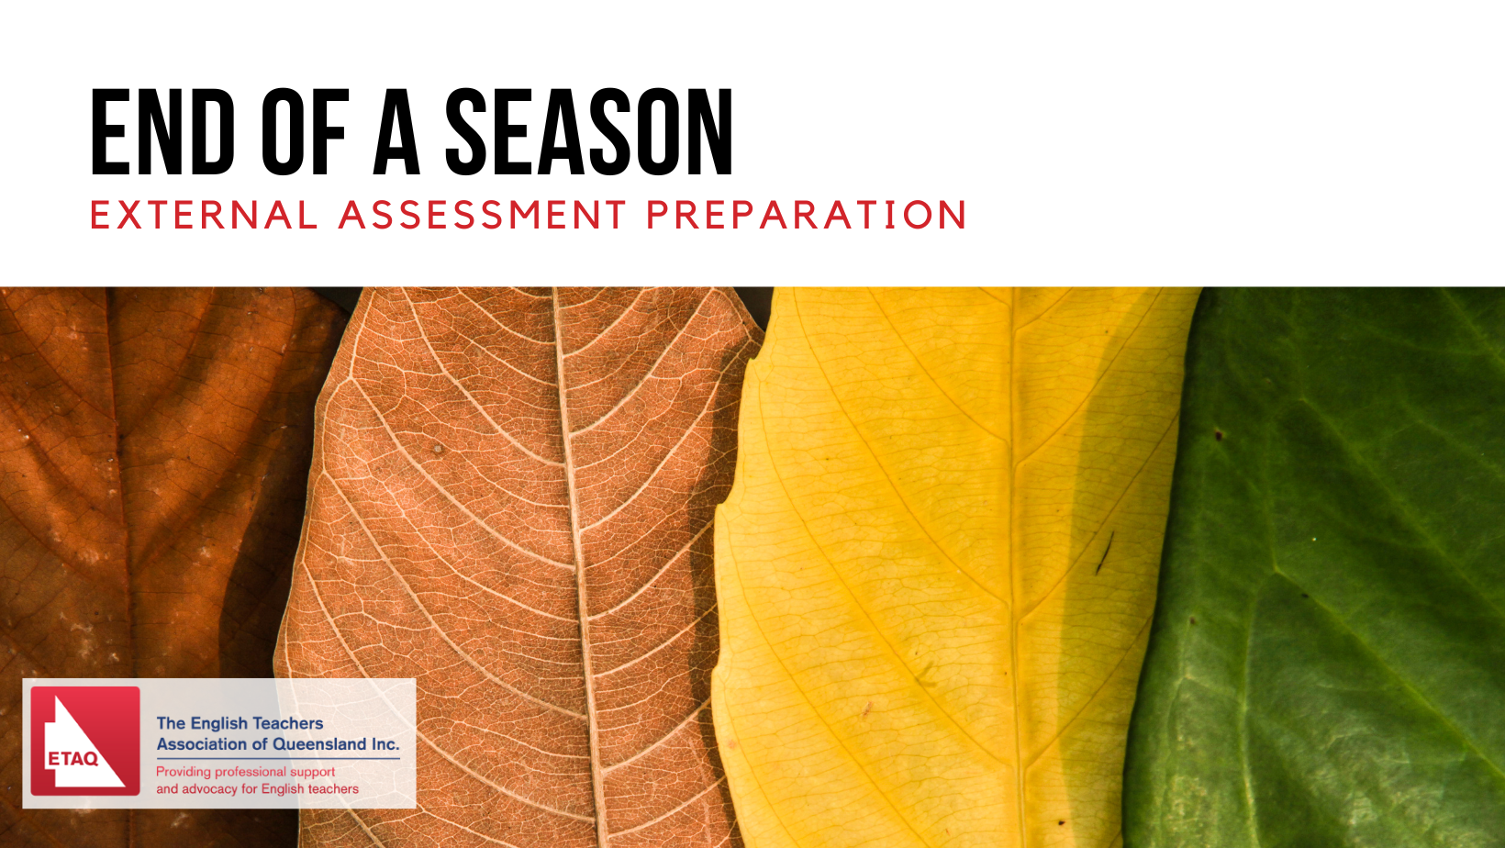
Teacher Event | Saturday 22 July 2023
Release of recorded student material | Wednesday 26 July 2023
Student Zoom Meetings | Wednesday 6 & Saturday 9 September 2023
Now in its fourth year, our annual pre-external examination event draws on our collective learning from 2020-2022 to deliver just what teachers and students need to help you feel motivated and prepared. With the very generous assistance of academics across the university sector, these events will provide expert support for General English, EAL/D and Literature.
ELABORATION
Our flexible mixed delivery allows you to conduct your own version of our curated materials from the comfort of your own school or home – or a combination of both. The program will consist of three segments:
New! Updated Wuthering Heights materials by Professor Jessica Gildersleeve from USQ; and The Yield . Negotiations continuing for Catch 22 and Never Let Me Go.
- Online, self-paced teacher preparation materials.
- An online student and teacher segment, accessible via Vimeo, whereby schools can choose to run their own workshops at a convenient time, using the pre-recorded materials
- Teachers register their class and can participate in a real time Q&A with their students on Wednesday 6 or Saturday 9 Sept.
Pre-recorded materials will remain available to all participants until the examination week in October.
An individual student can register independently for the student segments.
PRICING
 | Members | Non-members | Individual Student
External Assessment Preparation | Member & Class:  $50 | Non-member & Class: $75 | $10
www.etaq.com.au

