Senior Syllabuses Draft 2: English, Essential English, Literature, English as an Additional Language
ETAQ response, September 2016

Introduction

The English Teachers Association of Queensland (ETAQ) has provision for both individual and school corporate membership and a conservative estimate of membership coverage extends to at least 2800 teachers. It has a reach across the state and across schooling sectors and has a history of strong advocacy for English teachers.

ETAQ ran a strongly attended seminar in August at which views around the syllabuses were canvassed. Our response is based on this feedback as well as that of a range of other teachers and education professionals.

In some areas of this response we have been able to distil key points of agreement from those consulted to offer recommendations. In other areas we offer our insights as general advice about current professional ideas or concerns.

Rationale
Feedback indicates that most teachers are finding it confusing to have most of the English subjects with almost the same rationale. The rationale is a useful place to begin the process of differentiating between the subjects.

At present the rationale and the teaching and learning sections of the syllabus are practically the same for every subject in the English Learning Area. It would assist English teachers to make these more specific. For example in the Literature syllabus the only points where clear differences are identified are in the text selection section and the genres set for assessment. It is unclear what the key differences are between what is studied in English vs Literature apart from different texts. Same distinctions will need to be made clear between all syllabuses - the current rationales would be better described as ‘overviews’, as the focus is on generic information about the content of English in general.

Terminology across the syllabus is not consistent and difficult sometimes to follow eg. terms like genre, style, text type, form, mode, and medium are used interchangeably at times or without thought as to which is the best word. Words like elements, conventions, structures, features and ‘prose fiction’ vs ‘novel’ are also used inconsistently.

Recommendation 1: [NB. repeated from our draft 1 consultation - this issue remains unaddressed] That the language of the rationale sections include clearer direction about the points of difference in content/focus (i.e. literature, media, personal, or community/workplace texts) and difficulty (e.g. perhaps language ‘competence’ for Essential English and EAL vs language ‘mastery’ in English and Literature).

Recommendation 2: We suggest the rationale sections should contain information needed for readers to glean the ‘rationale’ i.e. reason/reasoning for why each course is important and why a student would select that course.

Recommendation 3: Inclusion of further terms in the subject specific glossary, including (but not limited to): genre, style, text type, form, mode, and medium.

Conceptual framework

Recommendation 4: We suggest creating additional visual representations of the five English subjects, to represent their points of overlap and difference.

Unit content
The objectives are the same as the previous syllabus. Now that the core learning is more prescriptive is it time to look at the wording of these? For example in Units 3 and 4 the core learning expects students to experiment with text structures and language whereas the C standard for the objective is to use.

The content between different units in both ENG and Lit syllabus is still difficult to determine. What is needed is to pull out everything that is the same in the core learning and put that in the rationale or teaching and learning section and only have the specific things for each unit listed to make it easier for teachers to identify the key differences between particular units of work.

Recommendation 5: We suggest that the language is checked carefully between individual syllabuses to ensure consistency within each document and between individual English syllabuses.

Assessment

Feedback on the tasks identified at this stage has been mostly positive. Members identified the choice of analytical exposition as a logical choice for the externally set and marked task.

Some expressed great concern about the level of prescription for tasks and modes of writing/speaking. For English, the choice of persuasive oral in unit 3 matches with teacher demand whilst some strongly preferred to have a creative/imaginative spoken task.

The cognitive verbs in Units 1 and 2 are unclear. It is hard to understand what words like explore and consider actually look like in the classroom despite the definitions at the end of the document. There needs to be greater clarity about what the students are actually doing - eg. analyse/evaluate.

Are schools going to be able to play with the structure of the units eg. In Unit 3 can schools complete the area of study 2 before completing area of study 1? Does the interpretive have to be the first assessment for unit 3 for English? Does the persuasive have to be spoken for English? Schools would appreciate any possible flexibility where possible to decide what works best in their context.

Recommendation 6: That choice is available for schools between speaking and writing as long as the purpose of each has been covered and the modes have been covered.

Analytical response (within English syllabus this wording is inconsistent throughout the document - response, essay, critical at the start with this word left out in the later specifications for this task) has been identified as a key genre within the new syllabus. Concern has been expressed that there is a strong need to identify just what is required for analytical response - to what extent is opinion required? Can the English version of analytical response be defined separately and specifically as opposed to the forms of exposition required by other subjects? Lindsay Williams has been doing work in this area and consultation with him on this issue would be of great benefit.

Recommendation 7: We suggest that the genre for analytical response is carefully considered across the syllabuses and made consistent with definitions offered as to its purpose and style requirements, especially as pertains to the externally set and marked tasks.

The relative importance of ‘Textual Features’, compared to the ‘Knowledge Utilisation’ and ‘Organisation and Development’ was identified as one of concern. For all written tasks, it was considered that ‘Textual Features’ should remain of high relative importance. This matches with community perceptions that this criterion is critical to success in any English subject. A strong message from members is that this importance does not change, from English to English Essentials to EAL or Literature. Feedback was also received that it remained just as important for English Extension.

Recommendation 8: We suggest that for written tasks ‘Textual Features’ should remain of equal importance across English syllabuses.

Text selection

Feedback from members indicates that the text selection currently provided is appropriate to allowing schools and teachers best flexibility. Strong feedback indicated that schools were keen to include texts such as novel, play (year 11) and Shakespearean play (year 12), poetry and some combination of media texts.

The literary canon is identified as critical for Literature, however members were excited at the possibility of also exploring popular and young adult literature in this subject. Some members expressed concern that canonic literature would not be emphasised in the EAL subject, and that an overly strong language development focus would leave little room for developing a love of literature, but were happy when shown that Unit 4 of the EAL syllabus was based on a study of “literary texts from diverse times and places”.

One concern, with the reduction in the number of assessment items, is the possibility that some schools may be able to choose to have no assessment item which focuses predominantly on poetry. With the QCS test to be removed, the need for all students to be able to deal with this key genre may need to be quantified in some way to avoid its becoming merely tangential within a school’s program.

Another concern was the lack of consistency between syllabuses regarding terminology and genre categorisation. The following two extracts are provided to demonstrate this issue:

Extract 1: English syllabus text requirements:
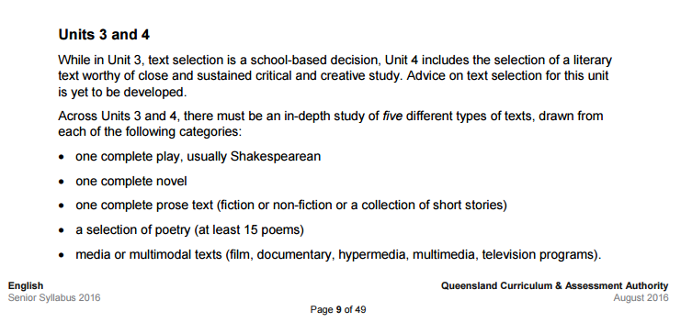

Extract 2: EAL syllabus text requirements:

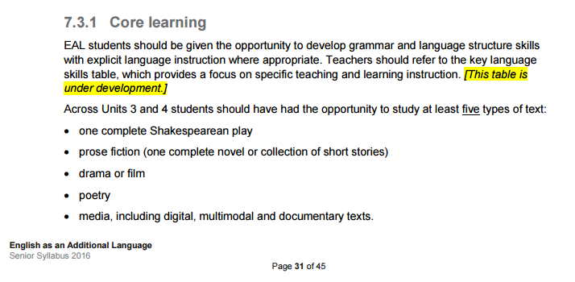
Some questions yielded by these extracts are:
- Why is a full Shakespearean play compulsory for EAL but not for English? (It should not be compulsory for either.)
- Why is studying a ‘complete’ text sometimes emphasised, but other times not? (Surely we can assume that ‘in-depth’ studies always involves reading the complete text?)
- Why is a number of poems specified for EAL but not English?
- Why are the elaborations describing what ‘media’ is different in each syllabus?
- If an experience of Shakespeare is seen as essential in these subjects, could his sonnets also be offered as a poetry option?

Text Selection

Recommendation 9: That a greater range of texts be available to select from for the external assessment in English than was provided for the Trial. We suggest providing options for poetry, drama, or novel study, as well as texts from a more diverse range of cultural settings. This will allow a better level of professional choice of how to engage with the imperative of unit 4, studying “literary texts from diverse times and places”.

Recommendation 10: That greater consistency between the syllabus documents is reached, e.g. if a certain number of poems is specified in an EAL Unit, we would expect a number of poems to also be specified in an English Unit.

Recommendation 11: We request the writers reconsider whether English in Units 3 and 4 is too heavy on reading as a language mode. English as a general area ought to provide better balance between written and visual texts, as well as text from print and screen media. This is what distinguishes the subject from Literature. Perhaps allowing an option for ‘one complete prose text OR one complete film’ could be a way forward.

Support of teachers for implementation

Teachers indicated that there was a need for a range of support to allow effective implementation. Some of these options included provision of annotated exemplars, banks of resources, practice questions and clear definitions (especially around analytical exposition). Ways in which teachers are keen to be supported include webinars, being sure to include regional teachers, seminars with QCAA/university and ETAQ experts as well as teacher to teacher seminars/webinars.

