ETAQ Saturday Seminar 2-2014
The Power of the Visual
Saturday 31 May, 2014
Brisbane Grammar School, 24 Gregory Terrace, Brisbane QLD 4000
Context
“Digital and online technologies continue to profoundly transform how members of Australian society work, meet, keep in touch, express themselves, share, build and store knowledge, and access material for pleasure and learning. Clearly, digital and online materials present the English curriculum with new teaching opportunities.” (Shape of the Australian Curriculum: English, 2009)
Purpose
Students of English evaluate, create and invent a wide range of texts in our classrooms. This seminar intends to provide a forum in which teachers share their knowledge and understanding of how we can explore and exploit multimodal texts in particular to enrich the teaching and learning of English.

Keynote Address:
‘Increasingly complex and sophisticated texts’: Computer games, literacy and design
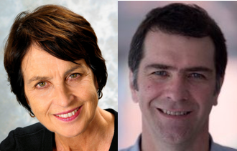

Presenters: Prof Catherine Beavis and
Dr Michael Dezuanni

Abstract
The Australian Curriculum: English has as its first aim that students need to “learn to listen to, read, view, speak, write, create and reflect on increasingly complex and sophisticated spoken, written and multimodal texts across a growing range of contexts with accuracy, fluency and purpose” (Australian Curriculum Assessment and Reporting Authority 2013). A central concept here is literacy as design. In an expanded view of literacy, where multiliteracies

and multimodal texts are seen as a central part of young people’s textual worlds, the incorporation and study of digital texts within English and related curriculum areas has become an important priority. Computer games, and digital games more generally, arguably epitomise new narrative and textual forms. While it is misleading to think of digital games as purely textual, they are quintessentially multimodal, combining a wide range of symbol systems in order to be able to be made, read and played. The Serious Play research project set out to understand more about the kinds of literacies and literacy practices entailed in computer games and game play, and what it might mean for teaching, learning and curriculum for computer games to be taken seriously as multimodal textual forms. In this presentation, we focus on two dimensions of this research. First, taking the example of Statecraft X, a ipod game designed to teach civics and citizenship, we focus on the kinds of ‘reading’ entailed in playing games, the ways in which readers/players understand and negotiate meaning through largely visual and multimodal forms, and the kinds of reasoning and collaboration that enables games to support learning in curriculum areas such as SOSE. In the second half of the presentation, the focus shifts to Minecraft, the highly popular commercial game, to explore matters of making and design, identity, creativity and display, and the ways in which such elements weave in and out of school and home-based play.

Keynote Presenters

Catherine Beavis is a Professor of Education at Griffith University. She teaches and researches in the areas of English and literacy curriculum, digital culture, young people and new media. Her research looks particularly at computer games and young people’s engagement with them, exploring the ways in which games work as new textual worlds for players, embodying and extending ‘new’ literate and multimodal literacies and stretching and changing expectations about reading, narrative and participation. Her current work explores literacy, learning and teaching in the digital age in the games-based classroom. It investigates how learners and teachers approach games, in and out of school differences, and what happens to literacy, curriculum and pedagogy when games are brought into the classroom.

Michael Dezuanni is a Senior Lecturer and researcher in the fields of digital cultures and arts education, with particular interest in digital media literacies. He is Deputy Director of Queensland University of Technology’s Children and Youth Research Centre and is a joint appointment in the Creative Industries and Education Faculties. He has been a chief investigator on several Australian Research Council and philanthropically funded projects, including an exploration of the relationship between media arts and literacy, remote music interactions, the use of iPads in kindergartens and digital games and learning. His most recent projects focus on digital inclusion in regional and rural Australia and the use of screen media resources in schools.

Program
Time | Activity
From 8:30 | Registration & tea/coffee
9:00 – 10:15 | Keynote address + questions
10:20 – 10:55 | Morning tea
11:00 – 12:00 | Workshop session 1
12:05 – 1:05 | Workshop session 2

This activity constitutes 3 hours & 15 minutes of Continuing Professional Development (CPD).

Workshop Sessions
Details of the workshops on offer are shown below. Participants will have the opportunity to attend two 60-minute sessions (11.00-12.00 and 12.05-1.05pm).
Workshop A
Panel power: Graphic novels in the English classroom – Di Laycock

Abstract
To date, teachers have leaned heavily on the use of picture books and film to address the analysis, appreciation and creation of visual texts, while graphic novels have hovered on the fringes waiting to be recognised for their potential as an engaging and meaningful format through which to develop students’ visual, cultural and critical literacies.

With the introduction of the Australian Curriculum: English, and in particular its Visual Language thread, the multimodality of graphic novels and their increasing availability as curriculum-appropriate texts provide teachers with a powerful vehicle to underpin students’ examination and creation of visual texts. Research suggests, however, that lack of understanding, and often misunderstanding, of graphic novels have made teachers somewhat hesitant in their uptake.

To illuminate and encourage the use of graphic novels in the English classroom, this workshop will provide a brief overview of the major codes and conventions of the graphic novel format. Examples drawn from my current doctoral research of the ways in which English teachers are using graphic novels will be considered, as will the benefits and challenges of that use.

Presenter

Di Laycock is a full-time teacher librarian at Barker College in Sydney. She is currently completing a Doctorate of Education at the University of Sydney on the topic of English teachers’ experiences with graphic novels. Di has published and presented on the educational use of graphic novels at national and international levels.

Workshop B
A framework for visual design for classroom application – A/Prof Beryl Exley

Abstract
This workshop introduces teacher participants to a framework of visual design that complements the model of language used in the Australian Curriculum English and can be employed in classroom activities to help students deconstruct and reconstruct visual texts. The hallmark of the framework of analysis suggested by Exley and Mills (2012) is its account of the social and cultural mores of the viewer as well as the viewer’s understanding of the social and cultural contexts of production and consumption. After an introduction to the framework of visual design, workshop participants are given an opportunity to apply the framework to compare two Coca-Cola Coke Zero advertisements targeted for the South Korean and Australian markets. These two texts draw on different visual designs but both seek to persuade the viewer to purchase the product. These points of difference reveal themselves only after a careful consideration of the social and cultural contexts of production and consumption and how they interface with the visual register. The workshop activities highlight the importance of using texts in context and using the theory of a ‘text-in-context’ model. The framework analysis can be taught to school students as is required by the Australian Curriculum English.

Presenter
Beryl Exley works in teacher education within the Faculty of Education at the Queensland University of Technology. She has a special interest in the teaching of grammar in classroom contexts, especially as it interfaces with multimodal texts (including visual design) and demands for engaging pedagogies that connect to students’ lived realities. Beryl has recently co-authored Playing with Grammar in the early years with Lisa Kervin and published by the Australian Literacy Educators’ Association and is currently writing the companion volume, Playing with Grammar in the primary years. Details of Beryl’s research publications are available at
http://eprints.qut.edu.au/view/person/Exley,_Beryl.html.

Workshop C
What’s wrong with how we think about genre? – Lindsay Williams

Abstract
For nearly twenty-five years, Queensland schools have embraced genre as an integral part of teaching students to write appropriately and effectively in a range of social contexts. Moreover, the conception of genre we work with is derived from Systemic Functional Linguistics research from the 1980s, for example, the structure of exposition is: Thesis, Arguments, Reiteration. However, these simple structures based around the organisation of content do not work so well when dealing with the complexities inherent in interactive multimodal texts. So, in this workshop, participants will explore ways of conceptualising genre that emphasise the dynamic nature of texts and recognise the importance of managing and organising interpersonal relationships, not just content.
Presenter
Lindsay Williams is an English and literacy educator with 30 years of experience in both the public and private sector. He currently works in teacher education at the University of Queensland, has his own consultancy business and is completing his PhD through the University of New England.

Workshop D
Re-imagining the classics: Accessible and practical approaches for using classic literature in the multimodal 21st century classroom – Fiona Roush and Cheryl Moore

Abstract

What do Wall E and Oliver Twist have in common? Can Austen feature as a poster on a teenager’s wall? The continuing rapid evolution of technology has meant that teachers of English have had to think quickly when it comes to engaging students. At times, however, we may review our unit planners with scepticism as we ponder, ‘is this activity for entertainment or education?’

In this workshop, participants will be shown practical ways a range of multimodal texts can be used to reinvigorate classic literature and enhance students’ depth of learning. From anticipatory sets to extension ideas, the session will demonstrate how to use visual texts to bolster lessons. Direct links to the Australian Curriculum will be outlined for each classroom idea presented. Participants are also encouraged to bring a USB if they would like any resources shown during the session.

Presenters
Secondary teachers Cheryl Moore and Fiona Roush have been colleagues at Sunshine Coast Grammar School for ten years and combined are the ideal Yin and Yang of English teachers. One is a former Hollywood script writer and the other an experienced Head of Faculty; both are keen life-long learners, eager to share their ideas for the English classroom.
Workshop E
(Trans)Forming meaning from the visual – Helen Johnston and Greg Howes
Abstract
With many students now remixing and reinterpreting others’ creative output, the directorial decision-making process is increasingly worthy of our attention. This workshop will outline three units across Years 10 to 12 that involve students engaging with visual texts and hypothesising, questioning, analysing and evaluating the effect of authorial decisions. In Year 10, our students assume a role on a film production panel, arguing for or against a proposed remake of the iconic Australian film, Breaker Morant. Done well, this involves a sophisticated understanding of the film, its context and its changing audience. In Year 11, students begin the year by deconstructing an Australian documentary and producing a review article that focuses on a particular representation of identity. Building on these experiences, they then undertake an elective unit in Year 12 in which they evaluate the success of a cinematic transformation of the novel they have studied.

The aim of this session is to provide attendees with some ideas and resources to help students think critically and creatively about visual texts.

Presenters
Helen Johnston has been Head of English at Brisbane Grammar School since 2011 and has taught in a range of schools in Australia and the US. She has been a member of the ETAQ Management Committee since 2011.

Greg Howes is Assistant Head of English at Brisbane Grammar School. Recent adventures in teacher librarianship have enriched his knowledge of and passion for reading, literacy and technology.

Workshop F
Exploring the nature of identity through the lens of contemporary Australian documentary films – Kathryn Emtage and Michelle Ragen

Abstract
John Grierson, a Scottish filmmaker and theorist, defined the documentary as the “creative treatment of actuality”. But as there is “no value-neutral treatment of actuality”, it is important that students learn to analyse how documentarians “translate knowing into telling” (Spence and Navarro, 2011). Accordingly, in Year 11, our students critically examine the structures and stylistic conventions, including the rich visual and aural aspects, of contemporary Australian documentary films. They also explore the nature of identity and how it is represented to others by identifying and analysing the choices made by the filmmakers.

In this workshop, the presenters will share key learning experiences, resources and samples of student work that stem from a close examination of Erica Bana’s Love the Beast (2009) and Tony Krawitz’s The Tall Man: Life in Paradise. Death in Custody. (2011). Love the Beast tells the story of one man’s search for identity amongst the mateship, mechanics and masculinity of suburban Melbourne. That this search is conducted by movie star, Eric Bana, becomes almost irrelevant as the documentary explores how one man’s passion for his ‘beast’ has shaped his lifetime. It invites students to view motor racing as a modern day ‘campfire’, a metaphoric gathering place that sates our yearning for danger, story-telling and belonging. Released two years later, the critically acclaimed documentary The Tall Man tells the story of the death of Cameron Doomadgee, an Aboriginal man, who, in 2004, was arrested for swearing, and 45 minutes later was found dead in a Palm Island watch-house cell. It also goes into the complex series of events that followed. Featuring a plurality of voices and expert accounts, the students are drawn into this tragic true crime story, as they examine what the text suggests about identity and how it is influenced by social, economic and environmental factors.

All participants will receive a booklet with examples of student worksheets and suggested activities, as well as a reference list to support the teaching of Love the Beast and The Tall Man.

Presenters
Kathryn Emtage is an English teacher at Brisbane Grammar School. She is the Co-ordinator of Academic Services for the School’s boarding students and has taught boys for the past twelve years.
Michelle Ragen is an English teacher and a teacher librarian at Brisbane Grammar School. Prior to returning to Brisbane, Michelle was the Head of English at Kormilda College in Darwin. Michelle is a member of the ETAQ Management Committee, and was a recipient of the ETAQ Peter Botsman Award in 2011.

Workshop G
Digital stories: From production to assessment –Dr Kelli McGraw

Abstract
Digital storytelling is growing in popularity as a means of engaging students with both multimodal production and narrative composition. In this workshop, we will explore some resources for scaffolding students' digital writing and a range of approaches to digital storytelling as a genre. Digital stories that won awards in the ETAQ Digital Storytelling competition will be viewed as examples of successful student work during this session. Workshop participants will work together to ‘mark’ completed student work using an assessment rubric before discussing various ways that digital storytelling could be incorporated into a unit of work.

Presenter
Kelli McGraw is a lecturer in secondary English curriculum at Queensland University of Technology. Previously she worked as a teacher of high school English in South-western Sydney, NSW. Kelli is the Vice President of the English Teachers Association of Queensland.

Workshop Program

 | Session 1  (11:00 – 12:00) | Session 2  (12:05 – 1:05)
Workshop A
Panel power: Graphic novels in the English classroom
(Di Laycock)

Workshop B
A framework for visual design for classroom application
(A/Prof Beryl Exley)

Workshop C
What’s wrong with how we think about genre?
(Lindsay Williams)

Workshop D  Re-imagining the classics: Accessible and practical approaches for using classic literature in the multimodal 21st century classroom  (Fiona Roush & Cheryl Moore) | Session 1 only
Workshop E  (Trans)Forming meaning from the visual  (Helen Johnston & Greg Howes) | Session 1 only
Workshop F  Exploring the nature of identity through the lens of contemporary Australian documentary films  (Kathryn Emtage & Michelle Ragen) |  | Session 2 only
Workshop G  Digital stories: From production to assessment  (Dr Kelli McGraw) |  | Session 2 only

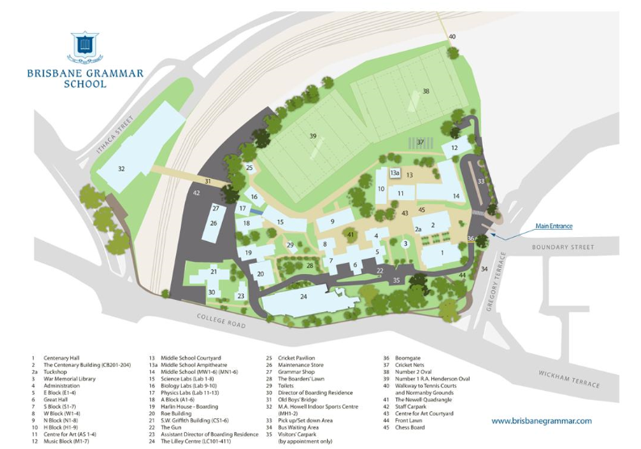
Map of Brisbane Grammar School
24 Gregory Terrace, Brisbane QLD 4000
No. 42 - Parking is available at the back of the School in the staff car park. To access this car park, you must turn left off College Road.
No. 24 - seminar venue (The Lilley Centre)

