THE ENGLISH TEACHERS ASS’N OF QLD INC

Invites you and your friends to a

Literary Spring Brunch

Saturday 21st October 2017

10:00 am to 12:00 Pm

Fiona will speak on the trans-formative power of bookclubs to challenge us and make us read out of our comfort zone. She will pose the question: What would a Bookclub Revolution look like?
LOURDES HILL COLLEGE – Marian Court
86 Hawthorne Rd, Hawthorne QLD 4171

Guest Speaker: Fiona Stager

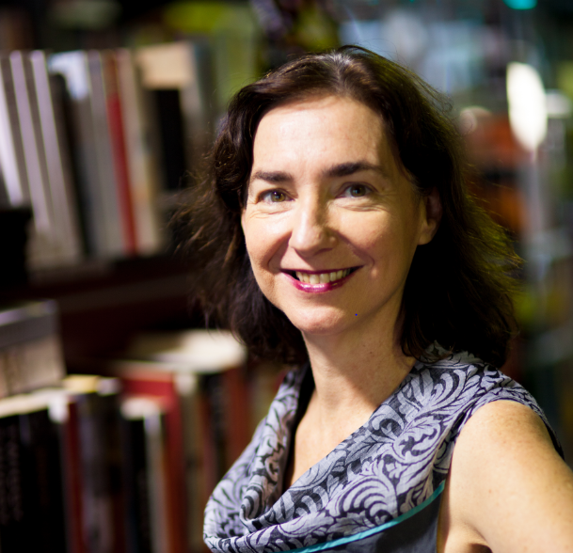
Fiona is the co-owner of Brisbane’s award winning bookshops, Avid Reader and Where the Wild Things Are. She has been a judge for the The Australian/Vogel's Literary Award, the Stella Prize and the Queensland Literary Awards. Fiona has been presented with the Johnno Award for services to the Queensland writing community and in 2014 the Australian Booksellers Association made her a life member. She lives in West End with her family, four chickens and a native bee hive.

ETAQ Members $40 RSVP Friday 13 October
Non-members $45
Registration form …/

