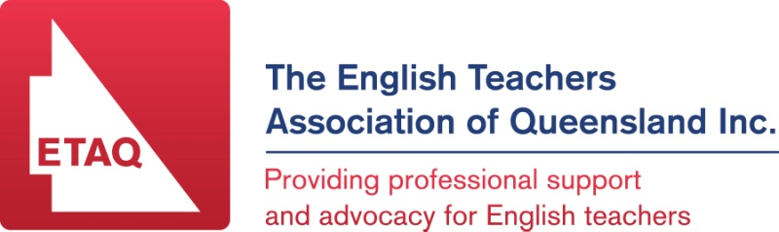

English Communication Forum

Engagement in English Communication

English Communication is a subject that is selected by students for a variety of reasons. As teachers it is imperative that we are able to connect with each student and help engage them with the curriculum. At times, this engagement can be a catalyst for success, not only in their senior schooling, but beyond.
The 2016 English Communication Forum aims to provide strategies by (and for) teachers of this subject to help increase engagement in the classroom. Through collaborating and sharing ideas, we can all seek to ensure that students in English Communication, not only connect with the coursework, but learn the skills required to function effectively within society.
In response to this need, ETAQ is offering an afternoon seminar so that practitioners may share high quality, practical materials. A Certificate of Attendance will be provided for CPD purposes.

WHEN: Thursday 20th October (3.30 – 5.50 pm)
Afternoon tea will be served from 3.30 – 4pm

WHERE: Northside Christian College, 151 Flockton Street, EVERTON PARK

COST: $20 for members and $30 for non-members

RSVP: Friday 14th October 2016

Time | Activity
From 3:30 | Registration & afternoon tea/coffee
4:00 – 4:15 | Welcome address (15 mins)
4:15 – 5:00 | Workshop session 1 (45 min)  Engagement – The First Stepping Stone To Learning  Melanie Ralph, Indooroopilly State High School
5:05– 5:50 | Workshop session 2 (45 min)  Activities For Classroom Engagement Within English Communication  Kirsty Bell and Bebe Monaghan, Marsden State High School

