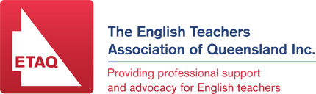

English Communication Forum –

Liberating Through Literacy

English Communication is now the English of choice for about a third of Senior students in Queensland. Its vital role in the curriculum makes it imperative that we continue to develop and refine quality learning experiences and assessment for this diverse cohort.

Many students who chose English Communication struggle with their literacy. This can leave them feeling isolated and struggling with the basic literacy skills required in order to be successful in both school and their future workplaces.
How can we engage these students while also teaching them the vital literacy skills that they so clearly need? How can we find age appropriate resources and teaching strategies that will improve literacy skills while also encouraging higher order thinking?
In response to this need, ETAQ is offering an afternoon seminar so that practitioners may share high quality, practical materials. Copies of any handouts will be made available so that those who attend will take away more than just inspiration and of course, a Certificate of Attendance will be provided as well for CPD purposes.

WHEN: Thursday 26th February (3.30 – 5.45 pm)
Afternoon tea will be served from 3.30 – 4pm

WHERE: Ipswich Girls’ Grammar School, Cnr Queen Victoria Parade & Chermside Road, East Ipswich

COST: $20

RSVP: Friday 20th February 2015

Time | Activity
From 3:30 | Registration & tea/coffee
4:00 – 4:20 | Welcome address (20mins)
4:25 – 5:05 | Workshop session 1 (40 min)  Using Digital Literacy to Bridge the Communication Divide  Juliette Bentley, Mt St Michael’s College
5:05– 5:45 | Workshop session 2 (40 min)  MoneySmart – Keeping The Context Real  Robyn Bergmansons, Principal Project Officer, Moneysmart Teaching

